

Create a Change Request and Validate Status Code

Learning Objective
The objective of this session is to learn how to create a change request in ServiceNow and validate the status code using Postman.

Expected Completion Time
- Best Case: 15 minutes
- Average Case: 20 minutes

Session Details
- ServiceNow API Credentials:
Go to https://developer.servicenow.com/dev.do#!/home ,Login with your Mail id & password , Click on Your profile Icon & Click Manage Instance Password & Obtain your ServiceNow
  - Obtain your Instance URL , Username & Password.
  - Example
URL: http://dev109834.servicenow.com
Username: Admin
Password: k6C8-ajUWqY%
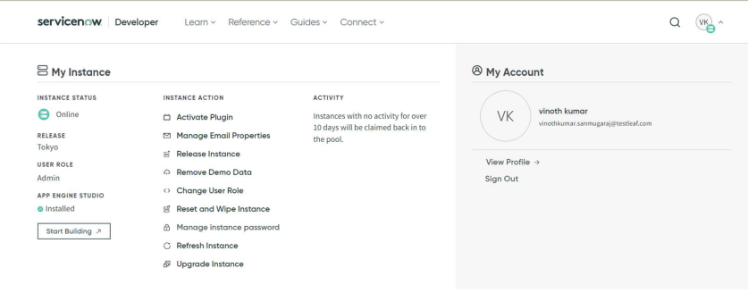

- Create a Change Request in ServiceNow:
  - Step 1: Create a Blank collection
    - Create a workspace(if you don’t have) and New collection
  - Step 2: Create a New Request
    - Click on New and select HTTP Request.
    - Name your request appropriately, e.g., "Create_Change_Request".
  - Step 3: Set Up the Request URL
    - Set the request type to POST.
    - Enter the ServiceNow API endpoint for creating a change request.
https://<your_instance>.service-now.com/api/now/table/change_request
Step 4: Authentication
    - Go to the Authorization tab.
    - Select Basic Auth.
    - Enter your ServiceNow Username and Password.
  - Step 6: Body
    - Switch to the Body tab.
    - Select raw and choose JSON from the drop-down menu.
    - Enter the JSON payload for the change request. Example:
{
"short_description":"Create incident via postman",
"description": "My first incident"
}

  - Step 7: Send the Request
    - Click Send.
    - Observe the response in the lower pane Body Tab. You should receive a JSON response containing details of the newly created change request, including the change request number.
    - 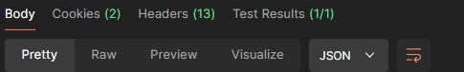

- Validate Status Code:
  - Step 1: Check Response Status Code
    - Look at the status code in the response section.
    - A successful creation will return a 201 Created status code.
  - Step 2: Verify Response Body
    - Ensure that the response body contains the necessary details such as the sys_id and number of the change request.
    - Example response:
- {
- "result": {
- "parent": "",
- "reason": "",
- "watch_list": "",
- "upon_reject": "cancel",
- "sys_updated_on": "2024-06-18 10:13:33",
- "type": "normal",
- "approval_history": "",
- "number": "CHG0030003",
- "test_plan": "",
- "cab_delegate": "",
- "requested_by_date": "",
- "state": "-5",
- "sys_created_by": "admin",
- "knowledge": "false",
- "order": "",
- "phase": "requested",
- "cmdb_ci": "",
- "delivery_plan": "",
- "contract": "",
- "impact": "3",
- "active": "true",
- "work_notes_list": "",
- "priority": "4",
- "sys_domain_path": "/",
- "cab_recommendation": "",
- "production_system": "false",
- "review_date": "",
- "business_duration": "",
- "group_list": "",
- "requested_by": {
- "link": "https://dev273722.service-now.com/api/now/table/sys_user/6816f79cc0a8016401c5a33be04be441",
- "value": "6816f79cc0a8016401c5a33be04be441"
- },
- "change_plan": "",
- "approval_set": "",
- "implementation_plan": "",
- "universal_request": "",
- "end_date": "",
- "short_description": "created via postman",
- "correlation_display": "",
- "delivery_task": "",
- "work_start": "",
- "additional_assignee_list": "",
- "outside_maintenance_schedule": "false",
- "std_change_producer_version": "",
- "service_offering": "",
- "sys_class_name": "change_request",
- "closed_by": "",
- "follow_up": "",
- "reassignment_count": "0",
- "review_status": "",
- "assigned_to": "",
- "start_date": "",
- "sla_due": "",
- "comments_and_work_notes": "",
- "escalation": "0",
- "upon_approval": "proceed",
- "correlation_id": "",
- "made_sla": "true",
- "backout_plan": "",
- "conflict_status": "Not Run",
- "task_effective_number": "CHG0030003",
- "sys_updated_by": "admin",
- "opened_by": {
- "link": "https://dev273722.service-now.com/api/now/table/sys_user/6816f79cc0a8016401c5a33be04be441",
- "value": "6816f79cc0a8016401c5a33be04be441"
- },
- "user_input": "",
- "sys_created_on": "2024-06-18 10:13:33",
- "on_hold_task": "",
- "sys_domain": {
- "link": "https://dev273722.service-now.com/api/now/table/sys_user_group/global",
- "value": "global"
- },
- "route_reason": "",
- "closed_at": "",
- "review_comments": "",
- "business_service": "",
- "time_worked": "",
- "chg_model": {
- "link": "https://dev273722.service-now.com/api/now/table/chg_model/007c4001c343101035ae3f52c1d3aeb2",
- "value": "007c4001c343101035ae3f52c1d3aeb2"
- },
- "expected_start": "",
- "opened_at": "2024-06-18 10:13:33",
- "work_end": "",
- "phase_state": "open",
- "work_notes": "",
- "close_code": "",
- "assignment_group": "",
- "description": "",
- "on_hold_reason": "",
- "calendar_duration": "",
- "close_notes": "",
- "sys_id": "04bdbf6253320210478975e0a0490ee4",
- "contact_type": "",
- "cab_required": "false",
- "urgency": "3",
- "scope": "3",
- "company": "",
- "justification": "",
- "activity_due": "",
- "comments": "",
- "approval": "not requested",
- "due_date": "",
- "sys_mod_count": "0",
- "on_hold": "false",
- "sys_tags": "",
- "cab_date_time": "",
- "conflict_last_run": "",
- "unauthorized": "false",
- "location": "",
- "risk": "3",
- "category": "Other",
- "risk_impact_analysis": ""
- }
- }
  - Step 3: Validate the Status Code
    - In Postman, you can write tests to validate the status code automatically.
    - Go to the Tests(Scripts) tab and add the following script:
pm.test("Verify Status code", function () {
pm.response.to.have.status(201);
});

Expected Outcome
Upon completion, you should be able to:
- Understand how to use Postman to interact with ServiceNow APIs.
- Create a change request in ServiceNow via API.
- Validate the response status code to ensure successful creation of the change request.

